

**Computer Systems Engineering Technology**

**CST 120 – Embedded C Programming**

|  |  |
| --- | --- |
| Lab 04 – Intro to Interrupts | Name: Chris Thomas_ |
|  | Due Date: |
| Instructor: G Drouant Turn in Wednesday (4/20) by 11:59pm | |
| Possible Points: 100 | |
|  | |

# Parts List

You will need:

4– 1K Resistors

1-Pushbutton Switch

1– Arduino UNO

1-Protoboard

Wires

**Part 1**

In this lab you will use an external interrupt to control the state of 3 LEDs while a fourth LED continuously blinks – 1 second on, then 1 second off.

Start the lab by building the circuit in the schematic below.

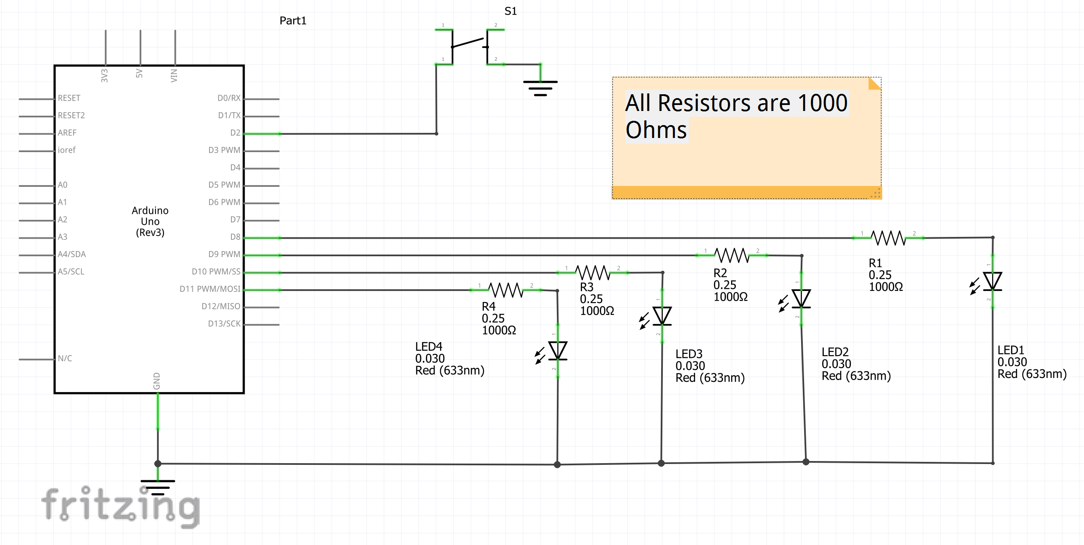

Next, write the code that will constantly blink LED1 Off and On at a rate of 1 second on then one second off. The push button switch (S1) will be used to produce an external interrupt on a low going edge. The external interrupt will toggle the state of LEDs 2, 3, and 4. Use the template below to write your code. Fill in the blanks with the proper code.

/*

Demo of using interrupts for doing what they do best --

two things at once.

Flashes LED0 at a fixed rate, interrupt toggles LED1 thru LED3 On and Off.

*/

#define *F_CPU* 16000000UL

#define ledmask 0x0E

#include <avr/io.h>

#include <util/delay.h>

#include <avr/interrupt.h>

int main(void){

PORTD |= blank;//activate pullup resistor on PD2

DDRB=blank;//set bottom 4 bits of PORTB as outputs

EIMSK |= (1<<blank);//enable external interrupt 0 (digital pin 2 on UNO - PD2)

EICRA |= (1<<blank);//trigger interrupt on falling edge of signal into PD2

*blank*();//enable global interrupts

/* blink LED 0 on and off - PB0 */

while (1)

{

PORTB|=blank;

*_delay_ms*(1000);

PORTB &=blank;

*_delay_ms*(1000);

}

}

ISR(blank)//interrupt service routine for external interrupt 0

{

PORTB ^= ledmask;//toggle state of LEDs 1 thru 3 (PB1 thru PB3)

}

Obtain the ISR vector from the vector interrupt table on the next page. Don’t forget to add “_vect” to the source name of the vector interrupt given in the table. For example, if you are writing an ISR for Timer/Counter1 Compare Match A we see that the source name is TIMER1 COMPA. The vector we would write in the ISR would be TIMER1 COMPA_vect – ISR(TIMER1 COMPA_vect). You will use External Interrupt 0 in your program.

Lab Sign off:______________2________

Send in this lab handout to canvas as well as your main.c code.

